

# Samsung Galaxy Tab S7 FE

## Type of device: Tablet

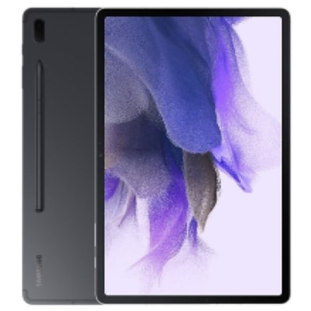

Actual Display Size : 12.4 inches

Operating System : Google Android

Version Number : Android 11

Network Capability : 3G,4G,5G

Year of Release : 2021

Average Price : $977 as of 24 09 2021

Internet Access : Wi-Fi Only

## Accessibility Features:

### Cognitive

* Additional Instructions
* Copy and Paste
* Flicker Free Display
* GPS
* Photo Telephone List
* Screen Timeout Disabled
* Simple Instructions
* Simple Reminders
* Simplify Display

Voice Notes

### Hearing Impairment and Deaf

* Allows for sign language communication
* Bluetooth or Wi-Fi
* Closed Captioning
* Front Facing Camera
* Hearing Aid Microphone Coupling
* Hearing Aid Telecoil Coupling
* Video Communications - Two-way

Visual Alerts - Incoming Calls

### Vision

* Accessibility APIs supported
* Battery Alert - Audible
* Bluetooth or Wi-Fi
* Braille Display Support
* Brightness Adjustable
* Dictation / Speech-to-Text
* High Contrast Mode
* Personalised Shortcuts
* Power Cue
* Screen Magnifier
* Screen Reader
* Text Size Adjustable
* Text Style Adjustable
* Voice Control /Personal Assistant

Voiced Menus

### Speech

* Allows for sign language communication
* Bluetooth or Wi-Fi
* Messaging Options - Email
* Messaging Options - IM

Predictive Text

### Physical

* Bluetooth or Wi-Fi
* Dictation / Speech-to-Text
* Gesture Based Navigation
* Headset - plug connected
* Predictive Text
* Reduced hand movement option
* Speaker-phone option
* Stylus or Prosthetic Device support
* Switch control option
* Visible Focus Indicators
* Voice Control / Personal Assistant
* Voice Recognition for Accessing Features

Voice Recognition for Dialling

## How and where to get it from?

You can buy this tablet from [Kogan](https://www.kogan.com/au/shop/category/tablets/?q=Samsung+Galaxy+Tab+S7+FE&page=1), [Dicksmith](https://www.dicksmith.com.au/da/shop/category/tablets/?q=Samsung+Galaxy+Tab+S7+FE&page=1), [JB HI-FI](https://www.jbhifi.com.au/search?query=Samsung%20Galaxy%20Tab%20S7%20FE&page=1&refinementList%5Bfacets.Category%5D%5B0%5D=Android%20tablets&refinementList%5Bfacets.Brand%5D%5B0%5D=SAMSUNG&refinementList%5Bfacets.Availability%5D%5B0%5D=Available%20Now), [The Good Guys](https://www.thegoodguys.com.au/SearchDisplay?categoryId=&storeId=900&catalogId=30000&langId=-1&sType=SimpleSearch&resultCatEntryType=2&showResultsPage=true&searchSource=Q&pageView=&beginIndex=0&orderBy=0&pageSize=60&searchTerm=Samsung+Galaxy+Tab+S7FE#facet:14013719710897120121328497983283557069,popup_14013719710897120121328497983283557069&productBeginIndex:0&orderBy:0&pageView:grid&minPrice:&maxPrice:&minHeight:160&maxHeight:333&minWidth:135&maxWidth:286.8&minDepth:10.7&maxDepth:33&pageSize:&), and other retailers.

## More information is available on:

[Samsung Galaxy Tab S7 FE Web Page](https://www.samsung.com/uk/tablets/galaxy-tab-s/galaxy-tab-s7-fe-5g-black-64gb-sm-t736bzkaeua/)

[Samsung Galaxy Tab S7 FE Support Web Page](https://www.samsung.com/ie/support/model/SM-T736BZKAEUA/#contact)

[Samsung Galaxy Tab S7 FE User Manual (PDF Download)](https://downloadcenter.samsung.com/content/UM/202105/20210528142340532/SM-T73X_UM_EU_RR_Eng_Rev.1.0_210514.pdf)